**Interaction network structure maximizes community-level plant reproduction success via niche complementarity**

Ainhoa Magrach1, Francisco P. Molina2, Ignasi Bartomeus2

Short running title: Network structure effects on ecosystem functioning

1Basque Centre for Climate Change-BC3, Edif. Sede 1, 1º, Parque Científico UPV-EHU, Barrio Sarriena s/n, 48940, Leioa, Spain

2Estación Biológica de Doñana (EBD-CSIC), Avda. Américo Vespucio 26, Isla de la Cartuja, 41092, Sevilla, Spain

# Supplementary material



**Figure S1.** Accumulation curves of pollinator, plant and plant-pollinator link richness with increasing sampling effort up to 100% sample coverage. Solid lines and points indicate observed richness while dashed lines show expected richness at increasing sample size, (i.e., extrapolated).

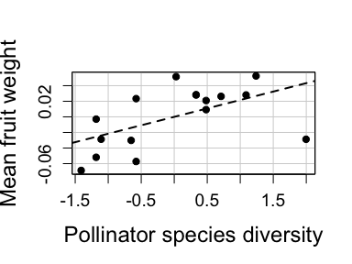

**Figure S2.** Partial residual plots showing the effect of the total number of pollinator visits received at the community level on the average fruit weight. Dots represent average vaues at the level of the community for all plant species considered (N=16 sites).

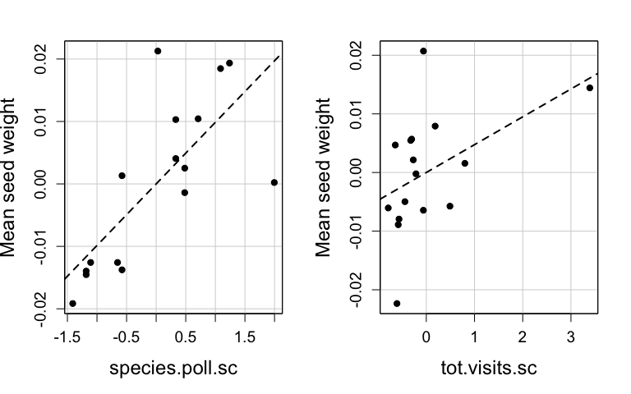

**Figure S3.** Partial residual plots showing the effect of the the diversity of pollinators and the total number of pollinator visits received at the community level on the average seed weight. Dots represent average vaues at the level of the community for all plant species considered (N=16 sites).

**Table S1.** Number of species sampled at each site.

|  |  |
| --- | --- |
| Site | Number of plant species |
| Aznalcazar | 4 |
| Bonares | 6 |
| ConventodelaLuz | 6 |
| CotitodeSantaTeresa | 5 |
| Elpinar | 1 |
| Elpozo | 2 |
| Esparragal | 4 |
| LaCunya | 3 |
| LaRocina | 5 |
| Lasmulas | 5 |
| Niebla | 6 |
| PinaresdeHinojos | 3 |
| Pinodelcuervo | 6 |
| Urbanizaciones | 4 |
| Villamanriqueeste | 1 |
| Villamanriquesur | 4 |

**Table S2.** Number of individuals per plant species sampled at each site.

|  |  |  |
| --- | --- | --- |
| Site | Plant species | Number of individuals |
| LaRocina | Anchusa azurea | 6 |
| Aznalcazar | Asphodelus fistulosus | 9 |
| Niebla | Asphodelus fistulosus | 9 |
| Pinodelcuervo | Asphodelus fistulosus | 6 |
| CotitodeSantaTeresa | Astragalus lusitanicus | 2 |
| CotitodeSantaTeresa | Cistus albidus | 6 |
| Bonares | Cistus crispus | 6 |
| Niebla | Cistus crispus | 5 |
| Pinodelcuervo | Cistus crispus | 6 |
| Villamanriquesur | Cistus crispus | 3 |
| Aznalcazar | Cistus ladanifer | 6 |
| Bonares | Cistus ladanifer | 12 |
| ConventodelaLuz | Cistus ladanifer | 9 |
| Lasmulas | Cistus ladanifer | 6 |
| Niebla | Cistus ladanifer | 9 |
| Pinodelcuervo | Cistus ladanifer | 9 |
| Villamanriquesur | Cistus ladanifer | 7 |
| Lasmulas | Cistus libanotis | 6 |
| PinaresdeHinojos | Cistus libanotis | 6 |
| Niebla | Cistus monspeliensis | 3 |
| Aznalcazar | Cistus salvifolius | 9 |
| Bonares | Cistus salvifolius | 9 |
| ConventodelaLuz | Cistus salvifolius | 6 |
| CotitodeSantaTeresa | Cistus salvifolius | 5 |
| Esparragal | Cistus salvifolius | 3 |
| LaCunya | Cistus salvifolius | 6 |
| Lasmulas | Cistus salvifolius | 7 |
| PinaresdeHinojos | Cistus salvifolius | 6 |
| Urbanizaciones | Cistus salvifolius | 6 |
| Villamanriqueeste | Cistus salvifolius | 3 |
| Bonares | Halimium commutatum | 6 |
| Esparragal | Halimium commutatum | 7 |
| LaRocina | Halimium commutatum | 3 |
| Lasmulas | Halimium commutatum | 2 |
| Pinodelcuervo | Halimium commutatum | 6 |
| Urbanizaciones | Halimium commutatum | 6 |
| ConventodelaLuz | Halimium halimifolium | 3 |
| Esparragal | Halimium halimifolium | 3 |
| LaRocina | Halimium halimifolium | 3 |
| Villamanriquesur | Halimium halimifolium | 6 |
| Aznalcazar | Lavandula pedunculata | 4 |
| Esparragal | Lavandula pedunculata | 6 |
| LaCunya | Lavandula pedunculata | 5 |
| Niebla | Lavandula pedunculata | 9 |
| Bonares | Lavandula stoechas | 9 |
| ConventodelaLuz | Lavandula stoechas | 3 |
| CotitodeSantaTeresa | Lavandula stoechas | 3 |
| Lasmulas | Lavandula stoechas | 9 |
| Urbanizaciones | Lavandula stoechas | 9 |
| Villamanriquesur | Lavandula stoechas | 3 |
| Niebla | Phlomis purpurea | 6 |
| PinaresdeHinojos | Retama sphaerocarpa | 1 |
| ConventodelaLuz | Rosmarinus officinalis | 9 |
| CotitodeSantaTeresa | Rosmarinus officinalis | 6 |
| Elpinar | Rosmarinus officinalis | 8 |
| Elpozo | Rosmarinus officinalis | 6 |
| LaCunya | Rosmarinus officinalis | 6 |
| LaRocina | Rosmarinus officinalis | 1 |
| Pinodelcuervo | Rosmarinus officinalis | 9 |
| Urbanizaciones | Rosmarinus officinalis | 9 |
| Elpozo | Spartium junceum | 6 |
| LaRocina | Spartium junceum | 3 |
| ConventodelaLuz | Teucrium fruticans | 9 |
| Bonares | Ulex australis | 6 |
| Pinodelcuervo | Ulex australis | 3 |

**Table S3.** Number of fruits per plant species sampled at each site.

|  |  |  |
| --- | --- | --- |
| Site | Plant species | Number of fruits |
| Aznalcazar | Asphodelus fistulosus | 22 |
| Aznalcazar | Cistus ladanifer | 4 |
| Aznalcazar | Cistus salvifolius | 10 |
| Aznalcazar | Lavandula pedunculata | 10 |
| Bonares | Cistus crispus | 15 |
| Bonares | Cistus ladanifer | 12 |
| Bonares | Cistus salvifolius | 14 |
| Bonares | Lavandula stoechas | 23 |
| Bonares | Ulex australis | 21 |
| ConventodelaLuz | Cistus ladanifer | 4 |
| ConventodelaLuz | Cistus salvifolius | 5 |
| ConventodelaLuz | Halimium halimifolium | 6 |
| ConventodelaLuz | Lavandula stoechas | 13 |
| ConventodelaLuz | Rosmarinus officinalis | 23 |
| ConventodelaLuz | Teucrium fruticans | 16 |
| CotitodeSantaTeresa | Astragalus lusitanicus | 2 |
| CotitodeSantaTeresa | Cistus albidus | 8 |
| CotitodeSantaTeresa | Cistus salvifolius | 11 |
| CotitodeSantaTeresa | Lavandula stoechas | 11 |
| CotitodeSantaTeresa | Rosmarinus officinalis | 16 |
| Elpinar | Rosmarinus officinalis | 23 |
| Elpozo | Rosmarinus officinalis | 36 |
| Elpozo | Spartium junceum | 13 |
| Esparragal | Cistus salvifolius | 4 |
| Esparragal | Halimium halimifolium | 7 |
| Esparragal | Lavandula pedunculata | 16 |
| LaCunya | Cistus salvifolius | 8 |
| LaCunya | Lavandula pedunculata | 11 |
| LaCunya | Rosmarinus officinalis | 18 |
| LaRocina | Anchusa azurea | 10 |
| LaRocina | Halimium commutatum | 6 |
| LaRocina | Halimium halimifolium | 1 |
| LaRocina | Rosmarinus officinalis | 8 |
| LaRocina | Spartium junceum | 10 |
| Lasmulas | Cistus ladanifer | 5 |
| Lasmulas | Cistus libanotis | 10 |
| Lasmulas | Cistus salvifolius | 7 |
| Lasmulas | Halimium commutatum | 3 |
| Lasmulas | Lavandula stoechas | 23 |
| Niebla | Asphodelus fistulosus | 19 |
| Niebla | Cistus crispus | 10 |
| Niebla | Cistus ladanifer | 2 |
| Niebla | Cistus monspeliensis | 4 |
| Niebla | Lavandula pedunculata | 15 |
| Niebla | Phlomis purpurea | 23 |
| PinaresdeHinojos | Cistus libanotis | 9 |
| PinaresdeHinojos | Cistus salvifolius | 9 |
| PinaresdeHinojos | Retama sphaerocarpa | 2 |
| Pinodelcuervo | Asphodelus fistulosus | 10 |
| Pinodelcuervo | Cistus crispus | 18 |
| Pinodelcuervo | Cistus ladanifer | 10 |
| Pinodelcuervo | Halimium commutatum | 7 |
| Pinodelcuervo | Rosmarinus officinalis | 11 |
| Pinodelcuervo | Ulex australis | 5 |
| Urbanizaciones | Cistus salvifolius | 10 |
| Urbanizaciones | Halimium commutatum | 8 |
| Urbanizaciones | Lavandula pedunculata | 8 |
| Urbanizaciones | Lavandula stoechas | 16 |
| Urbanizaciones | Rosmarinus officinalis | 22 |
| Villamanriqueeste | Cistus salvifolius | 6 |
| Villamanriquesur | Cistus crispus | 11 |
| Villamanriquesur | Cistus ladanifer | 4 |
| Villamanriquesur | Cistus salvifolius | 4 |
| Villamanriquesur | Halimium halimifolium | 10 |
| Villamanriquesur | Lavandula stoechas | 8 |

**Table S4.** Results of GLMM showing effect of simple visitation metrics on species-level average seed weight based on best model selected.

|  |  |  |  |
| --- | --- | --- | --- |
|  | Estimate | Std. Error | z value |
| (Intercept) | -3.74 | 0.42 | -8.97 |
| Pollinator species diversity | 0.15 | 0.40 | 0.37 |
| Total number of visits | -0.04 | 0.43 | -0.10 |

**Table S5.** Results of GLMM showing effect of simple visitation metrics on species-level average fruit weight based on best model selected.

|  |  |  |  |
| --- | --- | --- | --- |
|  | Estimate | Std. Error | z value |
| (Intercept) | -2.58 | 0.23 | -11.08 |
| Pollinator species diversity | 0.12 | 0.23 | 0.51 |
| Total number of visits | -0.02 | 0.24 | -0.09 |

**Table S6.** Results of GLM showing effect of simple visitation metrics on community-level average fruit weight based on best model selected.

|  |  |  |  |
| --- | --- | --- | --- |
|  | Estimate | Std. Error | t value |
| (Intercept) | 0.08 | 0.01 | 8.91 |
| **Pollinator species diversity** | **0.02** | **0.01** | **2.34** |
| Total number of visits | 0.01 | 0.01 | 1.26 |

**Table S7.** Results of GLM showing effect of simple visitation metrics on community-level average seed weight based on best model selected.

|  |  |  |  |
| --- | --- | --- | --- |
|  | Estimate | Std. Error | t value |
| (Intercept) | 0.02 | 0 | 9.27 |
| **Pollinator species diversity** | **0.01** | **0** | **3.82** |
| Total number of visits | 0.00 | 0 | 1.84 |

**Table S8.** Results of GLM showing effect of simple visitation metrics on equity in reproductive success across plant species within a community based on best model selected (0.50 threshold).

|  |  |  |  |
| --- | --- | --- | --- |
|  | Estimate | Std. Error | z value |
| (Intercept) | 2.52 | 0.97 | 2.60 |
| Pollinator species diversity | -0.28 | 0.99 | -0.29 |
| Total number of visits | 0.07 | 1.24 | 0.05 |

**Table S9.** Results of GLM showing effect of simple visitation metrics on equity in reproductive success across plant species within a community based on best model selected (0.75 threshold).

|  |  |  |  |
| --- | --- | --- | --- |
|  | Estimate | Std. Error | z value |
| (Intercept) | 0.53 | 0.58 | 0.91 |
| **Pollinator species diversity** | **-0.91** | **0.67** | **-1.36** |
| Total number of visits | -0.06 | 0.65 | -0.10 |

**Table S10.** Results of GLM showing effect of simple visitation metrics on equity in reproductive success across plant species within a community based on best model selected (0.25 threshold).

|  |  |  |  |
| --- | --- | --- | --- |
|  | Estimate | Std. Error | z value |
| (Intercept) | 4.09 | 2.40 | 1.71 |
| Pollinator species diversity | -1.41 | 2.11 | -0.67 |
| Total number of visits | -0.55 | 2.14 | -0.26 |